Leeds Playhouse in partnership with Tutti Frutti

Jerwood Resident Designer

Recruitment Information Pack
This residency is supported by the Jerwood Developing Artists Fund

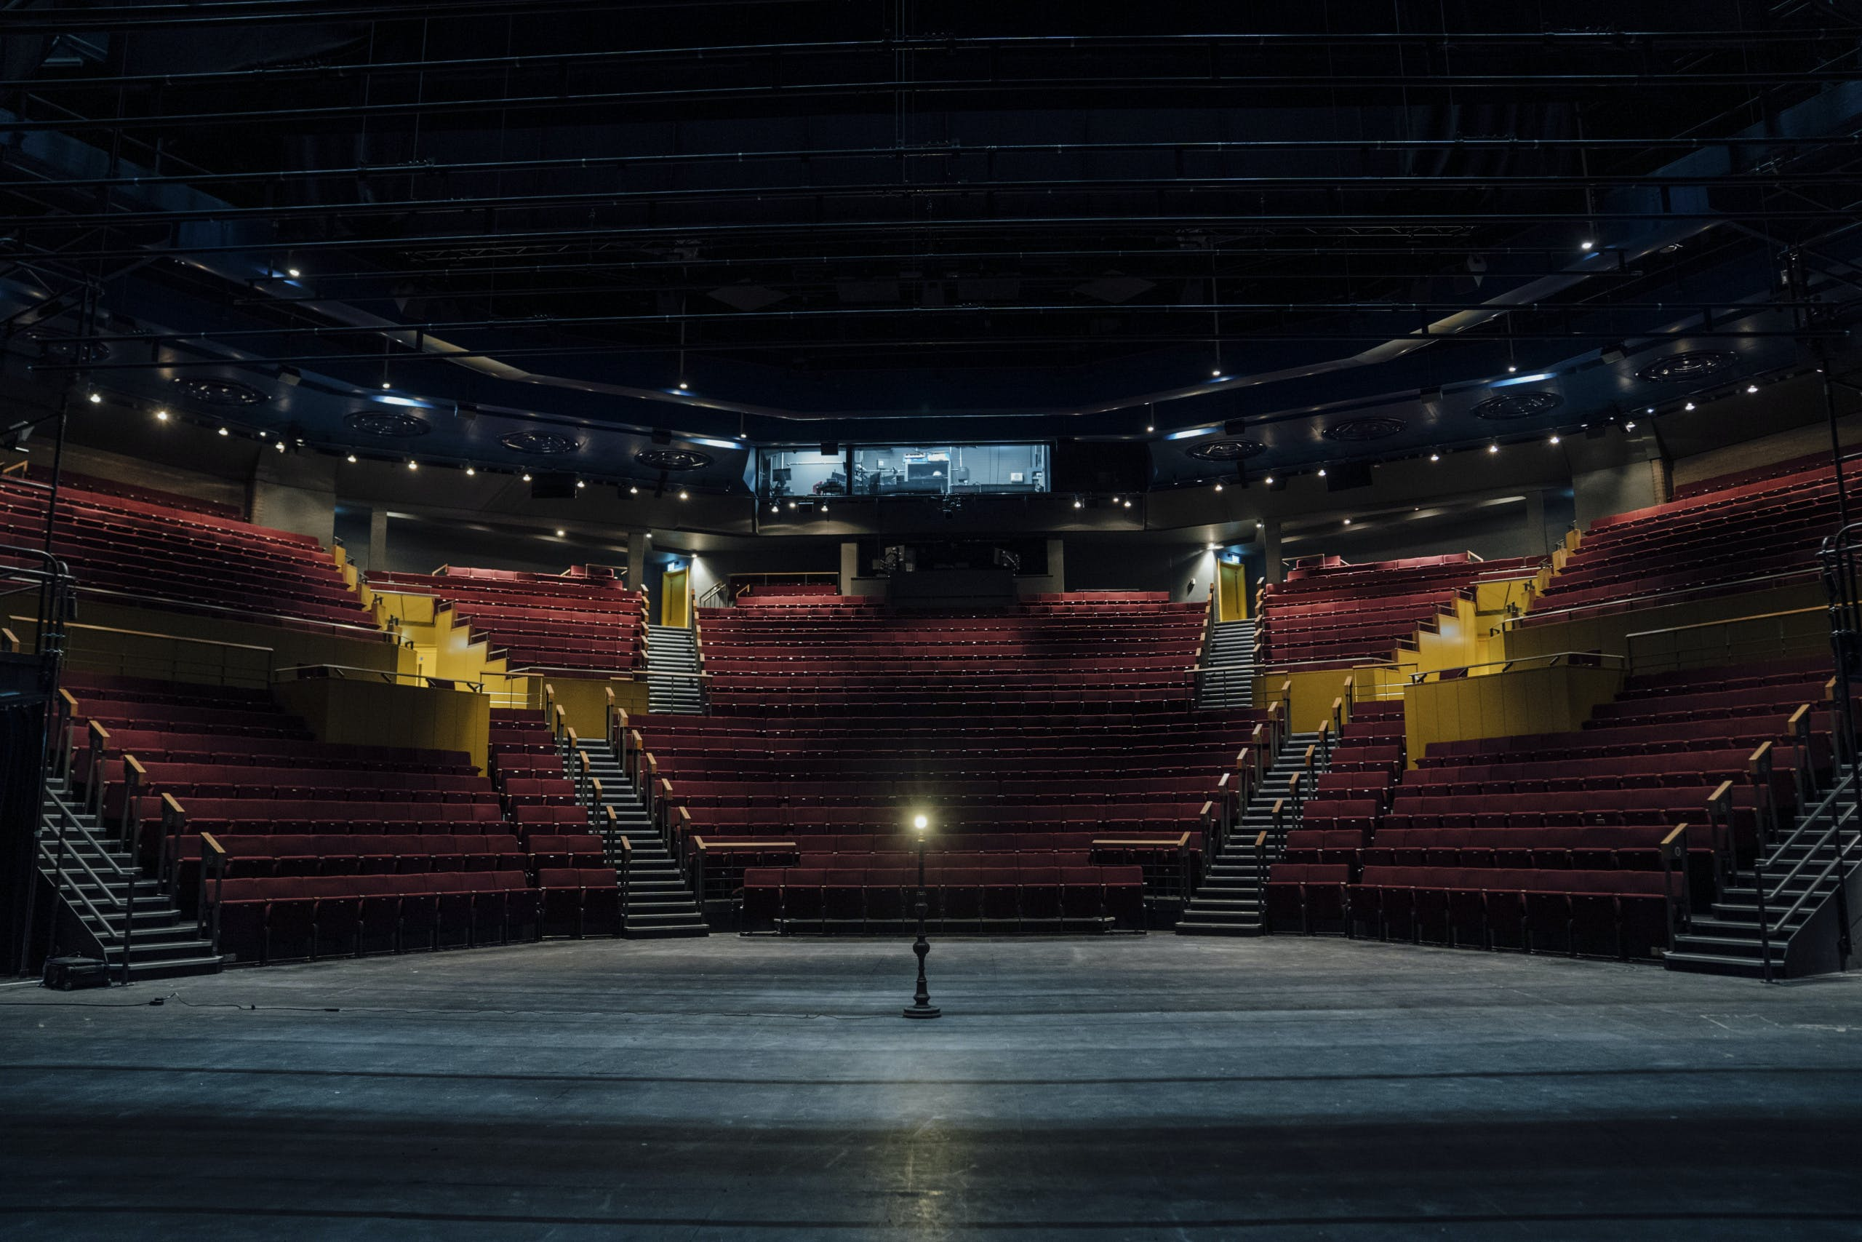
If you require a different format of this Recruitment Pack, please let us know by email to recruitment@leedsplayhouse.org.uk
Contents

Page 3 About You

Page 4 Who are Leeds Playhouse?

Page 5 Who are Tutti Frutti?

Page 6 Why have we created a Resident Designer role?

Page 7/8 The Role – What might it include?

Page 9 Key Information

Page 10 What support will you get in the role?

Page 11 Skills, Experience, Values – What are we looking for?

Page 12 What is it like to be a Resident Designer?

Page 13 How to apply?

Page 14 What happens next?

Page 15 Checklist

We hope this pack will give you plenty of information before applying. But if you do have any further questions, please don’t hesitate to drop our Production Co-ordinator, Bik-Yuk Wan, an email at production@leedsplayhouse.org.uk for a chat before applying.

The deadline for this application is MONDAY 13th MAY at 10am.

About You
Leeds Playhouse and Tutti Frutti are looking for a Jerwood Resident Designer to join us full time for one year from 8th July 2024 to 4th July 2025.
You will be a Set & Costume Designer in the early stages of your career. You will be imaginative, passionate about visual storytelling, and a good collaborator.
You will share the ethos of Leeds Playhouse and Tutti Frutti that art should be accessible to and inclusive of everyone and want to join us in working to achieve these aims.
You will be interested in a wide-ranging opportunity – to work in and learn from a large building-based theatre organisation, as well as to spend time within a small touring theatre company.
You will be generous spirited, hard-working, creative and curious. You will be flexible and open to making the most of all of the opportunities that may arise throughout the year.
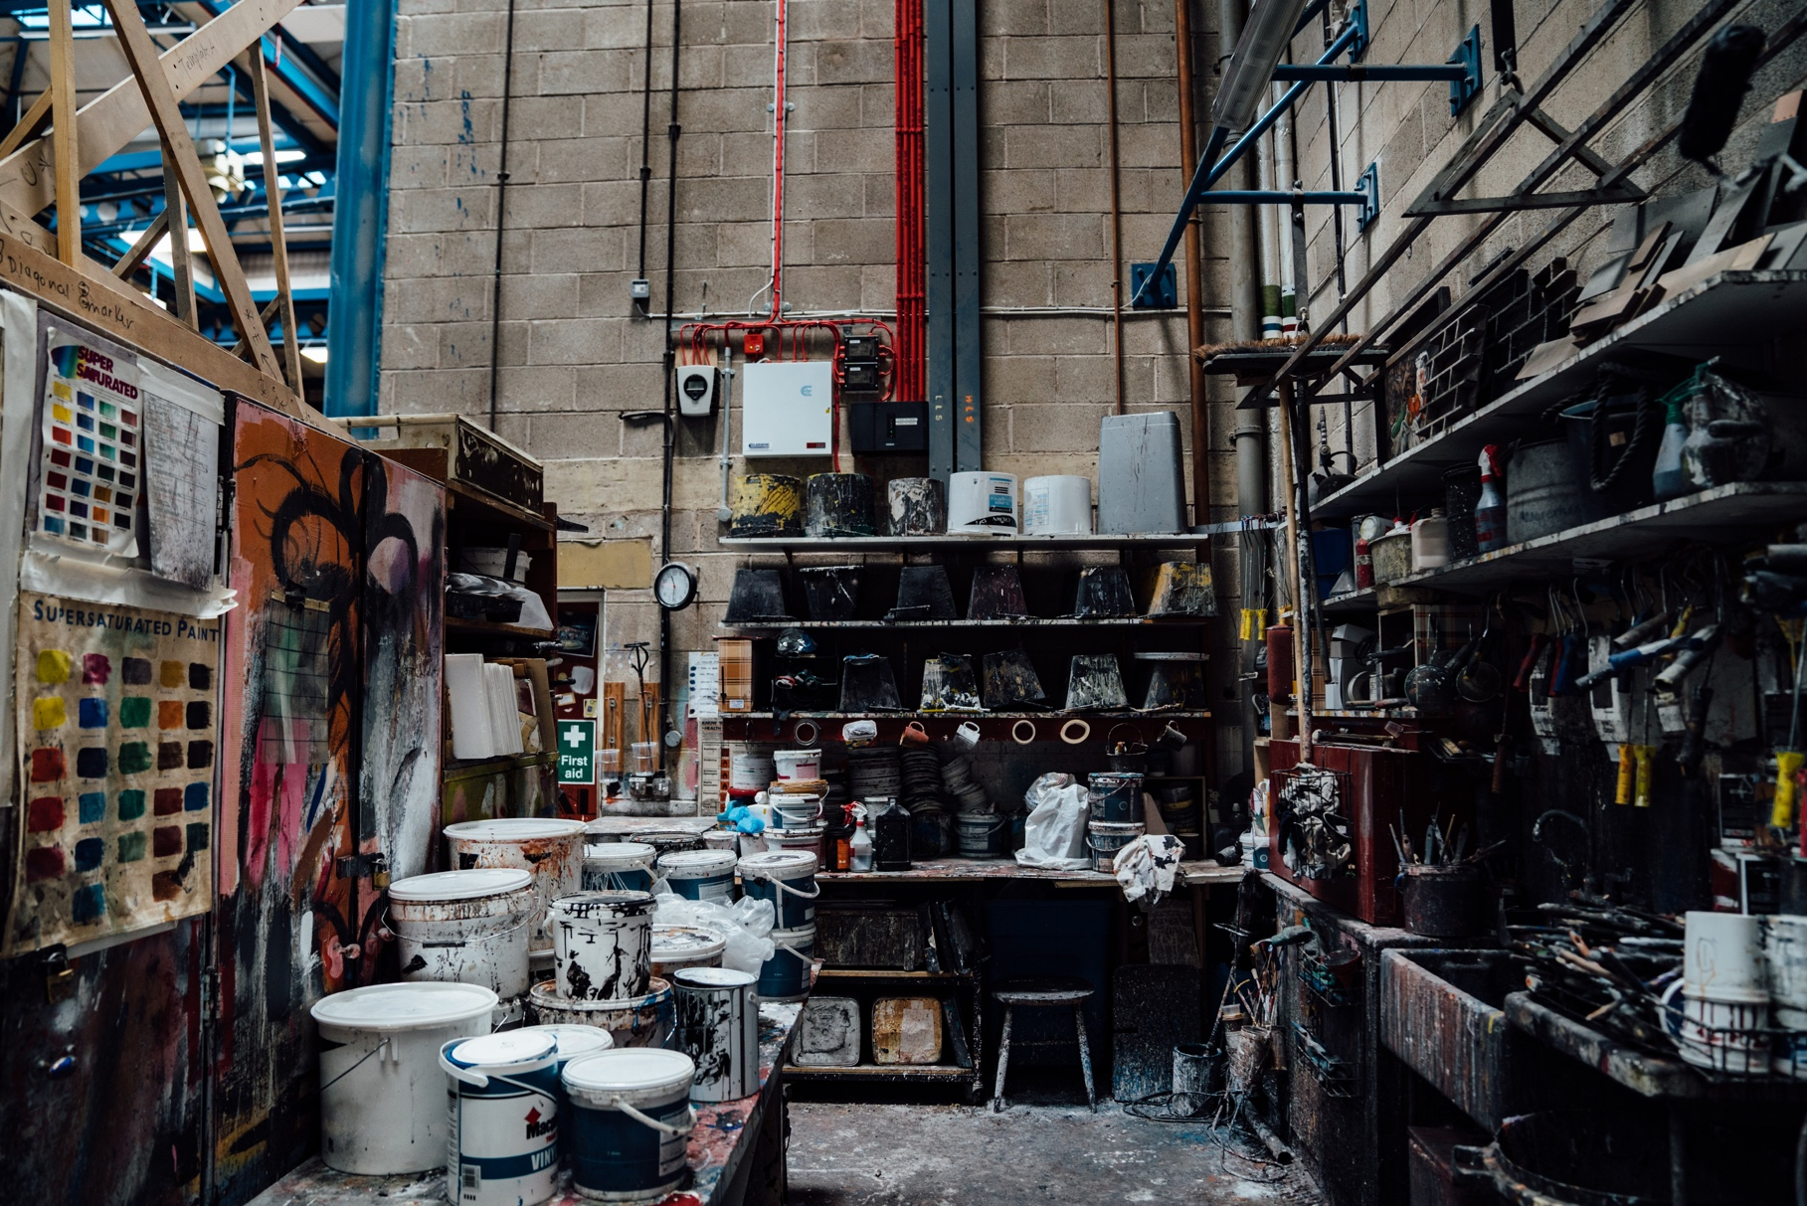
You will be based in West Yorkshire/the Leeds City Region.

Who are Leeds Playhouse?
Leeds Playhouse has been welcoming audiences for 50 years. It’s a cultural hub, a place where people gather to share stories and to engage in world class theatre. Its innovative, sector-leading Playhouse Connect programme engages with thousands of people in the region each year through weekly workshops and creative projects. This includes its Artistic Development programme, Furnace, which nurtures and supports locally rooted artists across three career stages – entry level, early career and established.

Committed to making theatre available to everyone, the Playhouse has been a pioneer of accessibility, being the first theatre to present Relaxed and Dementia Friendly performances and welcoming refugees and people seeking asylum by becoming the first Theatre of Sanctuary in the world. We were voted Most Welcoming Theatre at the UK Theatre Awards 2022.

Leeds Playhouse has three theatre spaces:
- Quarry Theatre – 750 seat amphitheatre where the audience wraps around the stage
- Courtyard Theatre – 400 seat end-on theatre where the audience faces the stage
- Bramall Rock Void – flexible studio theatre which can seat up to 130 people

As well as producing productions in our theatre spaces, we tour work nationally and internationally. Each year we tour productions to community spaces across the city of Leeds, and we are ever increasing our presentation of theatre and arts activity across digital channels.

You can find out more about Leeds Playhouse by watching this film https://youtu.be/AT98G3fWhvQ or on our website www.leedsplayhouse.org.uk.
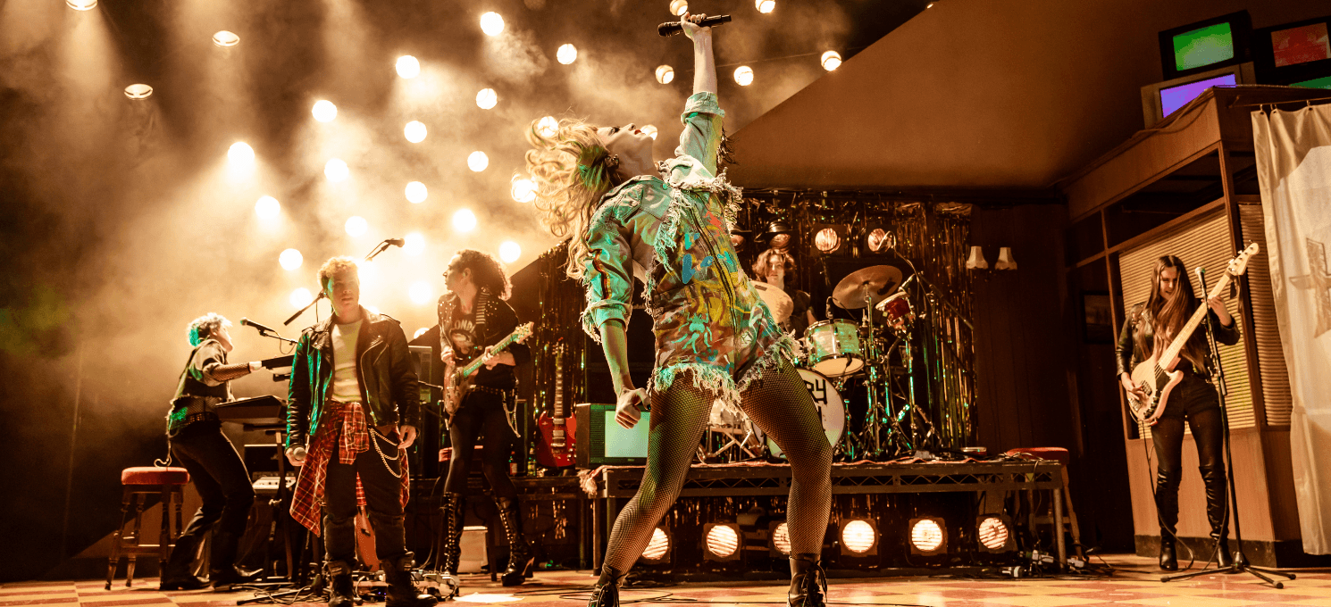

Who are Tutti Frutti?
Tutti Frutti specialises in bringing fantastic, distinctive, diverse and carefully crafted shows to children aged 3+, their families and teachers across the UK and the world. We’re a Leeds based company who create imaginative, visual, meaningful theatre. Our values sit under these headings: working together, children and family, to be the best we can be, and change is possible. Tutti Frutti tour the UK with newly commissioned productions for children, internationally to the USA and run the Leeds based Tutti Frutti club for young children to engage in creative activity.
Tutti Frutti has previously supported assistant designers to help them develop their design skills for children’s theatre. This has included experience at our research and development workshops where artists meet to explore the ideas for a new show, and assisting our show designers, going through the whole design process from ideas to completion of set and costumes.
We will work with Leeds Playhouse to offer an opportunity to learn more about the specifics of touring theatre nationally and internationally for young audiences and offer access to the workings of a touring company.
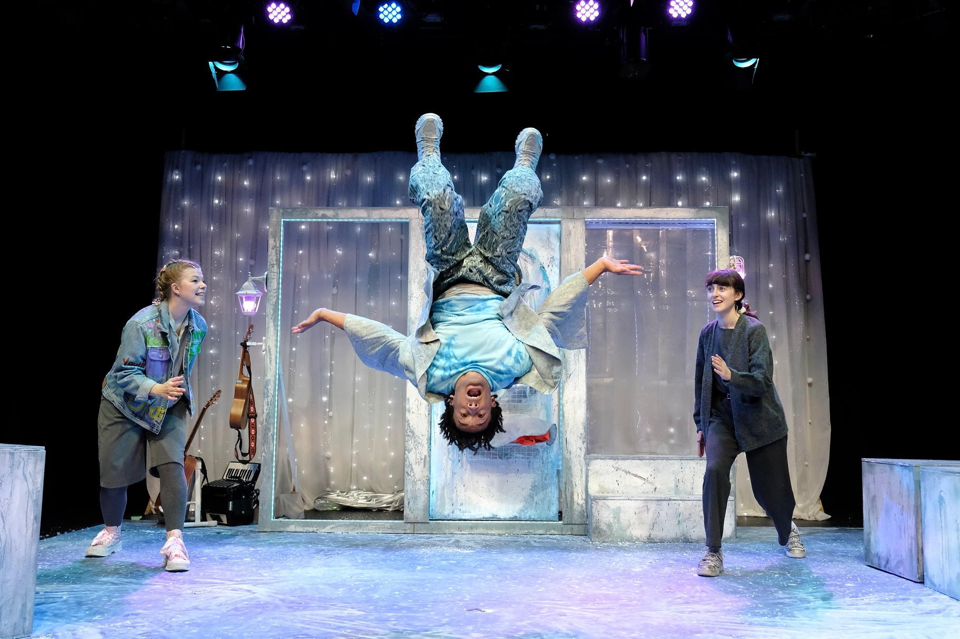
Find out more about us: www.tutti-frutti.org.uk

Why have we created the Jerwood Resident Designer role?

Because:
- There is a lack of artist development opportunities for design roles in the theatre industry.
- We understand it’s challenging for early career designers to build a sustainable career and develop into bigger scales and spaces.
- Both organisations endeavour to support artists across Yorkshire, and to ensure this includes the development of designers who are locally rooted.
- We acknowledge that the theatre industry is not yet representative of all the people in the world we live in, and we are committed to increasing representation within theatre designers.
- We believe that having an employed, full time Designer will bring huge creative benefits to our organisations.

We are delighted to have the support of the Jerwood Developing Artists Fund to continue our development of Designers. Jerwood Foundation is a grant-making foundation dedicated to supporting excellence and emerging talent in the UK. Since 1991, the Foundation has donated over £110 million to support the arts and education. The Jerwood Developing Artists Fund offers exceptional opportunities for early-career artists, curators and producers, delivered by organisations with the capacity and know how to help individuals to develop new skills, ideas and work. You can find out more here.
To apply, you must:
- Be in the early stages of your design career. By early stages, we mean that you have started your career as a Designer and have some professional experience (paid and unpaid). This might include designing for a professional theatre or theatre company; training in design or another discipline with transferrable skills (eg: art, architecture, fashion, textiles); working as an assistant designer; designing in Fringe theatre; designing for non-theatre based events such as Carnival parades. We recognise that you may have faced barriers to training and gaining design-based work previously and we welcome applications from those who may not have taken a traditional route or who are coming to a design career in later life.
- Be based in West Yorkshire/the Leeds City Region. This is because Leeds Playhouse and Tutti Frutti are committed to nurturing our local ecology, so even if you are happy to commute from further afield, you are not eligible to apply for this role.
- Have the legal right to work in the UK.
- Not be in full or part time formal education and be over 18 years of age.
We welcome diversity in all its forms, and we positively encourage deaf, disabled (including hidden disabilities) & neurodivergent people, African Diaspora people, South, East and South East Asian people, people who identify as LGBTQIA+, people from culturally and ethnically diverse backgrounds and people who identify as working class or face barriers due to socio-economic status to apply.

The Role

This is a role which will provide a wide-ranging opportunity to be part of the creative life of a large-scale building-based theatre organisation as well as to spend time with a small-scale touring theatre company. This is a unique opportunity for a locally rooted designer to work in a supportive environment surrounded by a wealth of expertise; to grow, build invaluable relationships across a range of departments, develop skills, create work at a larger scale than they have before, learn from highly experienced designers, and contribute to the development of the next generation of designers and technicians.

What might the role include?

This year-long role starts from 8th July 2024.

We hope the year will include many of the following opportunities at Leeds Playhouse:

- The opportunity to design at least one project for Leeds Playhouse, developing their creative practice and portfolio.

- Assist, shadow and talk to experienced theatre designers on shows in the Quarry and Courtyard Theatres.

- Be part of planning, championing and delivering artist development opportunities for a range of backstage and design elements, e.g. planning and running an ‘Introduction to Design course’ focussed on developing local designers from underrepresented backgrounds, delivering one-off design focussed workshops.

- Support and deliver sessions and projects within Playhouse Connect which champion backstage and design roles, e.g. run a Technical & Design Youth Theatre group, support backstage placements on community productions.

- A desk space and access to messy spaces in the Leeds Playhouse building for use in model making and planning.

- Access to the extensive Production Departments of Leeds Playhouse including Wardrobe, Props, Scenic Workshop, and Construction. This will involve practical, hands-on experience working within these departments.

- Access to learning how both a big organisation (Leeds Playhouse) and a smaller touring company (Tutti Frutti) work and are funded. This would include the opportunity to attend meetings such as Programming and Access & Inclusion.

- Opportunities to undertake non-show related design, e.g. designing our Leeds Pride parade entry, Front of House access displays and touch tours.

- Support to establish a wider network of relationships within the Yorkshire theatre ecology, and in creating opportunities for future employers to see your work, with a view to supporting your career beyond the end of the fellowship.

- Opportunities to see theatre at Leeds Playhouse, across Yorkshire and further afield.

- Opportunities to connect with the Jerwood Foundation.

- Access to a variety of the strategic partnerships Leeds Playhouse have such as Ramps on the Moon (which seeks to normalise the presence of deaf and disabled people on and off stage), and to be part of our Plan for Change specifically working to address the structural racism that we acknowledge is part of our organisation and industry.

We hope the year will include many of the following opportunities at Tutti Frutti:

- Access to research and development (R&D) workshops where artists meet to explore the ideas for a new show.

- Meeting with Tutti Frutti designers.

- Involvement in projects such as the Tutti Frutti Club.

Working as an assistant designer on the following productions: The Glass Slippers by Emma Reeves for a UK Tour and Christmas run; Underneath a Magical Moon by Mike Kenny for a run at Sheffield Crucible and USA tour in 2025; Assisting on a remake of The Ugly Duckling by Emma Reeves to be performed in Shanghai, China.

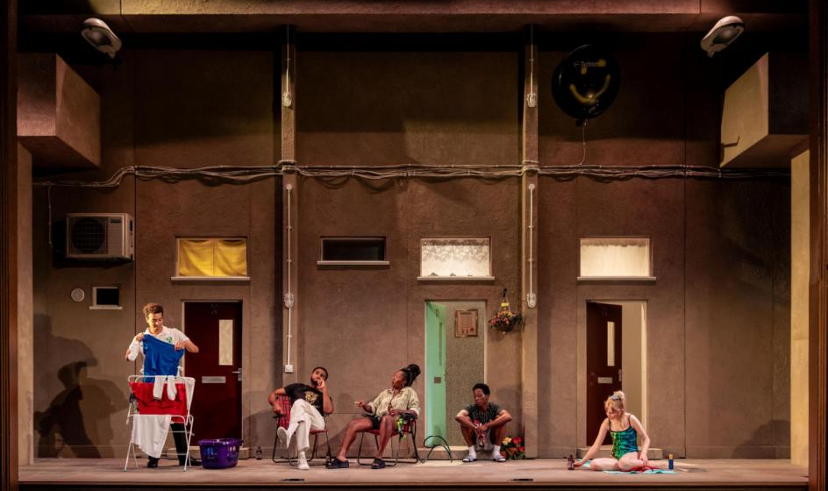
Key Information

Annual Salary: £21,000.
Model making and show seeing expenses will be provided on top of this salary.
Hours: 35 hours per week. Whilst normal working hours will be Monday to Friday 9.30-5.30pm (with an hour break for lunch), this role will require flexibility with some evening and weekend working required.
There may be occasions when you are required to work outside the normal hours outlined. In recognition of additional hours worked, you are entitled to Time Off in Lieu (TOIL) in line with the Playhouse TOIL policy.
Employment Type: Fixed-term, 12-month contract.
Annual Leave: 20 days per year plus bank/public holidays. The Playhouse is committed to making adjustments to working patterns of Muslim staff members during Ramadan and to enabling staff to take time off where possible for Eid or other religious festivals.
Probationary Period: Three months.
Notice Period: One month. One week during probationary period.
Place of Work: Your main base will be Leeds Playhouse, Playhouse Square, Quarry Hill, LS2 7UP. Some of your time will be spent at the Tutti Frutti offices at Hope House, 65 Mabgate, Leeds, LS9 7DL.
Location: For the duration of the residency, you must be based locally and within commuting distance of Leeds City Centre. There are no relocation fees available.

In the event that you attend the tech and dress rehearsal with Tutti Frutti in Alnwick or Sheffield, travel and accommodation will be provided where required.

DBS: We may ask you to complete a DBS check, which will cover you to work with vulnerable groups including children.

Access: We can provide support for reasonable adjustments you may need such as access requirements.

Benefits: Staff discount in food and drink outlets at Leeds Playhouse.
Complimentary and discounted tickets to shows at Leeds Playhouse.
Tickets & travel expenses to see theatre at other venues.
Contributory pension scheme.

What support will you get in the role?

Line Management
You will be supported by two key people at Leeds Playhouse. Your line manager will be Judith Cloke, our Technical Director who leads our Production Departments. You will also receive pastoral management support from Amy Leach, our Deputy Artistic Director.

Wider Support
You will work and develop as part of the team at two friendly and welcoming organisations. You will have support from colleagues across a range of departments at Leeds Playhouse and Tutti Frutti. You will have the opportunity to attend meetings and sessions with organisations that partner with Leeds Playhouse and Tutti Frutti strategically.

Access Requirements
We can provide support for reasonable adjustments you may need such as access requirements, and can make a referral to Scope to support Access to Work applications.

Buddy
You will have the opportunity to regularly meet with and chat to a previous Jerwood Resident Designer, to share your experiences and ask their advice.

Employee Support
As an employee of Leeds Playhouse, you will have access to a range of support including a referral pathway for in-house counselling, Care First mental health services (our employee assistance programme), our online micro-aggressions reporting tool, our HR & Learning team, as well as access to our Multi-Faith and Reflection Space.
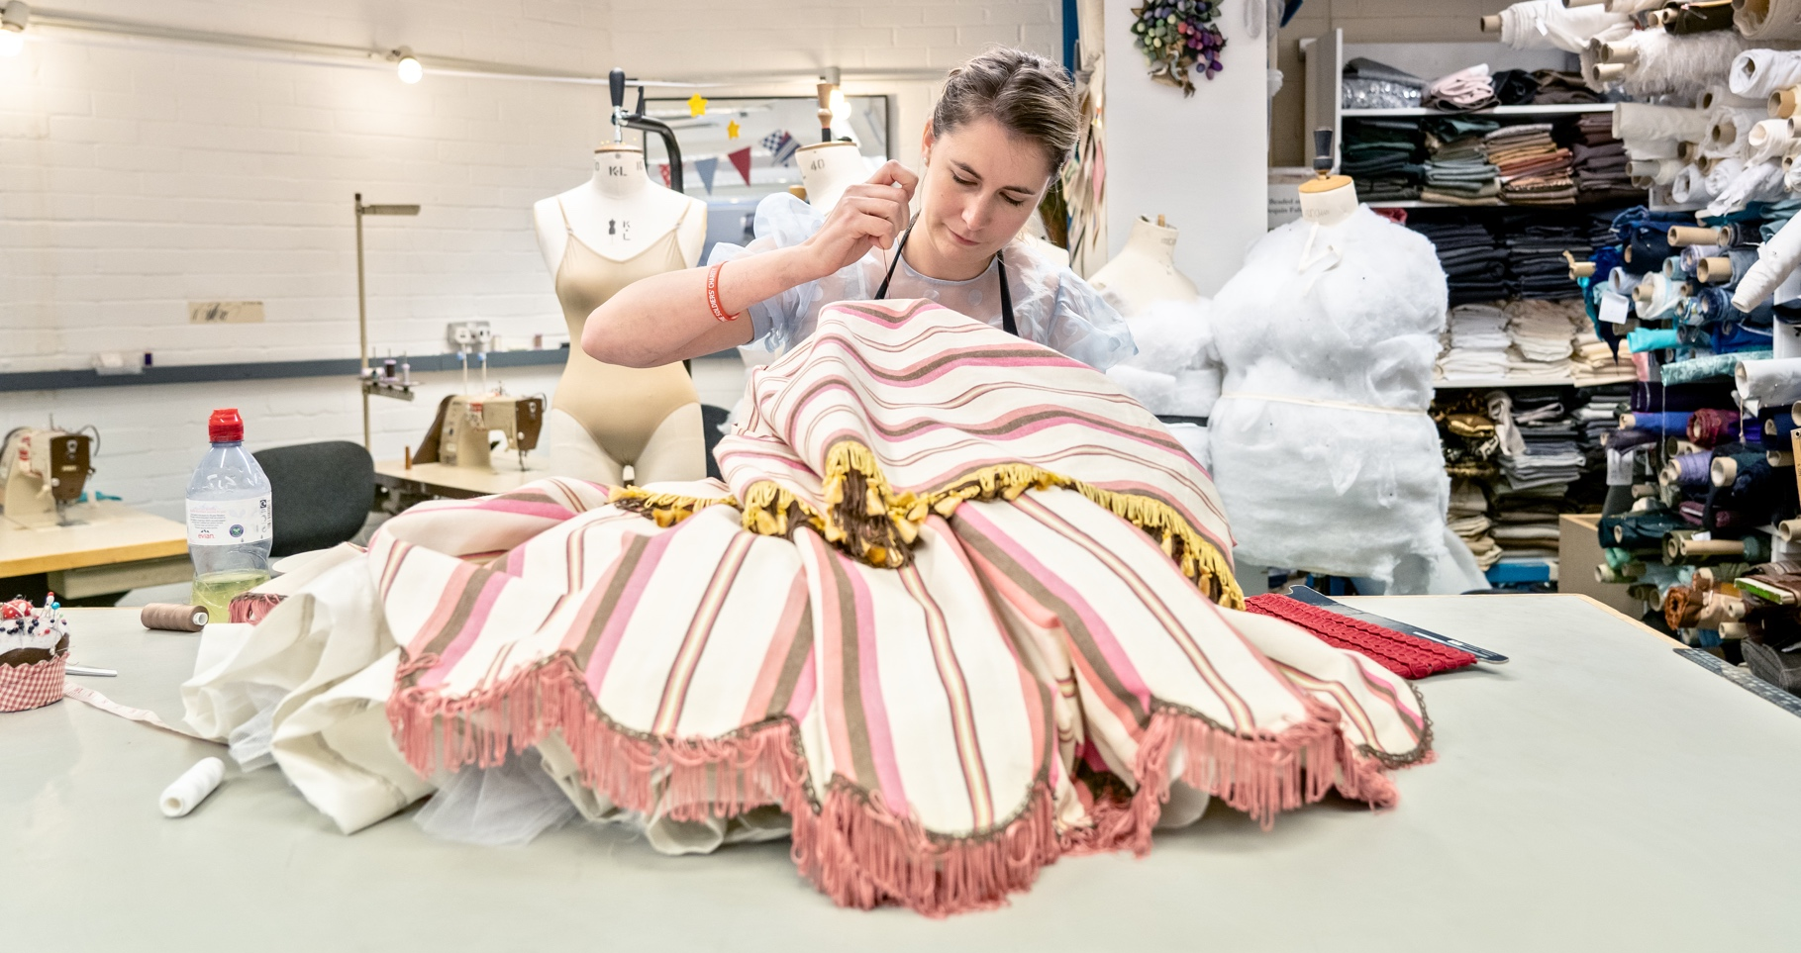
Skills, Experience, Values

We are looking for someone who:

- Is passionate about design and visual storytelling.
- Is interested in both Set Design and Costume Design.
- Is good at working together with people as well as being able to work well alone.
- Has good communication skills.
- Is willing to listen, learn, contribute and problem solve.
- Is flexible and adaptable, often in a busy working environment.
- Has enthusiasm, integrity and is prepared to try new things.
- Respects the dignity of other people and shares the ethos of Leeds Playhouse and Tutti Frutti that art should be accessible to and inclusive of everyone.
- Is excited about being part of supporting the development of a wider and more diverse network of theatre designers, such as through Youth Theatre or artist development opportunities.
- Has a curiosity for and interest in all kinds of theatre including theatre for children and theatre created and presented in community settings.
- Is curious, open and keen to get stuck in and to learn from the wide range of people and departments on offer at Leeds Playhouse and Tutti Frutti.
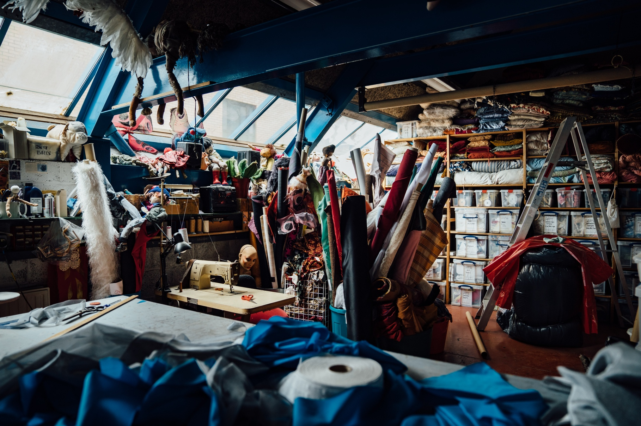
- Willing to learn more about and commit to the Theatre Green Book to help make theatre more environmentally sustainable.
What is it like being a Jerwood Resident Designer?

Warda Abbasi: Jerwood Resident Designer 2020-21

“I started out in the industry by teaching myself how to make miniature models of sets. The residency provided a great way to build on the skills I had taught myself with real life industry experience.

I found the residency life changing and had an incredible time during the year. My favourite parts were working with some amazing people. Everyone was very welcoming and had a wealth of knowledge with years of experience behind them, to guide and inspire me. I had the opportunity to shadow different departments and knew I could ask lots of questions and keep exploring new avenues. I assisted on shows and met lots of amazing designers, all of whom provided insights of their careers and gave invaluable advice. I made connections with people I still consider mentors and know I can still turn to if I need help.

If you think you don’t have enough experience to apply for this role, you should set aside any self-doubt. You’ll gain this experience through the residency, along with the confidence in your own ability. The people working with you are incredibly welcoming and supportive and will help you along the way; they’ll provide an invaluable network and assistance.”

Delicia Sorhaindo: Jerwood Resident Designer 2023-24

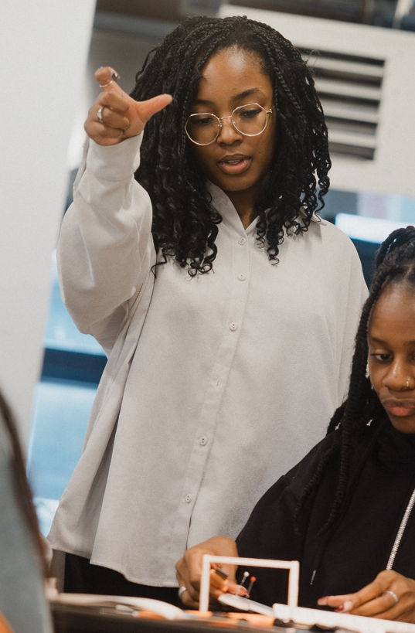
“I graduated with a degree in Costume Design and Making from Nottingham Trent University. I then went on to freelance on various projects before becoming the Jerwood Resident Designer in 2023.

During my year as the Resident Designer, I learnt so much from Leeds Playhouse and Tutti Frutti. I wanted to learn more about Set Design as it was not a discipline I was taught. From the moment I started the residency, I was able to use the skills I already had whilst learning so much about Set Design and the workings of theatre as a whole.

I had the opportunity to work with and learn from so many amazing people – from the staff at the Playhouse and Tutti Frutti, to all the amazing designers, creatives and theatre watchers. Everyone was so welcoming and so helpful in my creative journey. There is so much to learn and so much to see and experience. It’s truly an amazing opportunity.”
How to apply?

We guarantee to interview any candidate with a disability who shows in their application that they have the skills, experience and values needed for this role, subject to capacity. This commitment is part of our disability confident scheme.

Please answer the following questions. In answering these questions, think about the skills, experience and values we’re interested in which are listed on page 11. We’re interested in what you say rather than how you say it. So please answer in a format that best suits you and enables you to respond fully to the questions. This could be written English, video (BSL/spoken English/SSE), audio recording, bullet points, etc.

- Let us know your:
  - Name
  - Pronouns (eg: she/her, he/him, they/them)
  - Address (you must be based in West Yorkshire/Leeds City Region)
  - Email
  - Contact Phone Number
  - Do you have the legal right to work in the UK?
- Please tell us a little about your life and career journey so far. Why would this opportunity help you overcome any barriers you have faced and be the right next step for you? (write/record around 400 words)
- Please tell us about your design experience, paid or unpaid, both in and out of theatre. What are your strengths? (write/record around 300 words)
- What areas of theatre design do you need support in developing? What part of set and costume design do you think you need to learn more about? (write/record around 300 words)
- Share with us a photo or drawing of something you’ve designed that you’re proud of. Choose something that was part of telling a story, for example: a set or costume design, a Carnival costume, a doll’s house. Why have you chosen this design? What were you proud of? What would you improve? (write/record around 300 words)
- Please tell us about any experience you have in working with children or young people or teaching or leading workshops for artists? (write/record around 300 words)
- Tell us anything else you think will help us know more about you and your experience. (write/record around 300 words)
- Please tell us if you consider yourself disabled for inclusion in the disability confident scheme.
- Please share any access requirements you have and what barrier the adjustment is intended to overcome. Information you provide regarding your access requirements will not form part of the decision-making process. If, later on, you realise that you have access requirements that you haven’t included here, tell us as soon as you can.
Send your answers to production@leedsplayhouse.org.uk by Monday 13th May at 10am. In the subject line put “Jerwood Resident Designer Application". Please also complete the monitoring form here. A recruitment check list can be found on page 15.
We hope this pack has given you plenty of information before applying. But if you do have any further questions, please don’t hesitate to drop our Production Co-ordinator, Bik-Yuk Wan, an email at production@leedsplayhouse.org.uk to arrange a chat before applying.
What happens next?

- We need to receive your application by Monday 13th May at 10am. Late applications will not be considered.
- We will acknowledge receipt of your application within 5 days.
- If you are shortlisted, you will hear from us by email or phone. You will be invited to an informal first-round interview in the week commencing 20th May 2024. For the interviews, we will send you a photo and introduction to all the people on the panel, and we will also send you the list of questions in advance, so you have time to think about and prepare your answers.
- After the first-round interviews we will make a final shortlist of around 3 applicants. We will set a design task for these finalists. This task will take a maximum of 2 days and the finalists will be paid £200 each to cover their time in completing the task.
- Final interviews and sharing of the design task will take place in the week beginning 3rd June 2024.
- If you are not shortlisted for either of the stages, we will let you know as soon as we can. However, we hope to have more opportunities for Designers in the future so we hope that this application can be the start of a connection between you and Leeds Playhouse and Tutti Frutti.
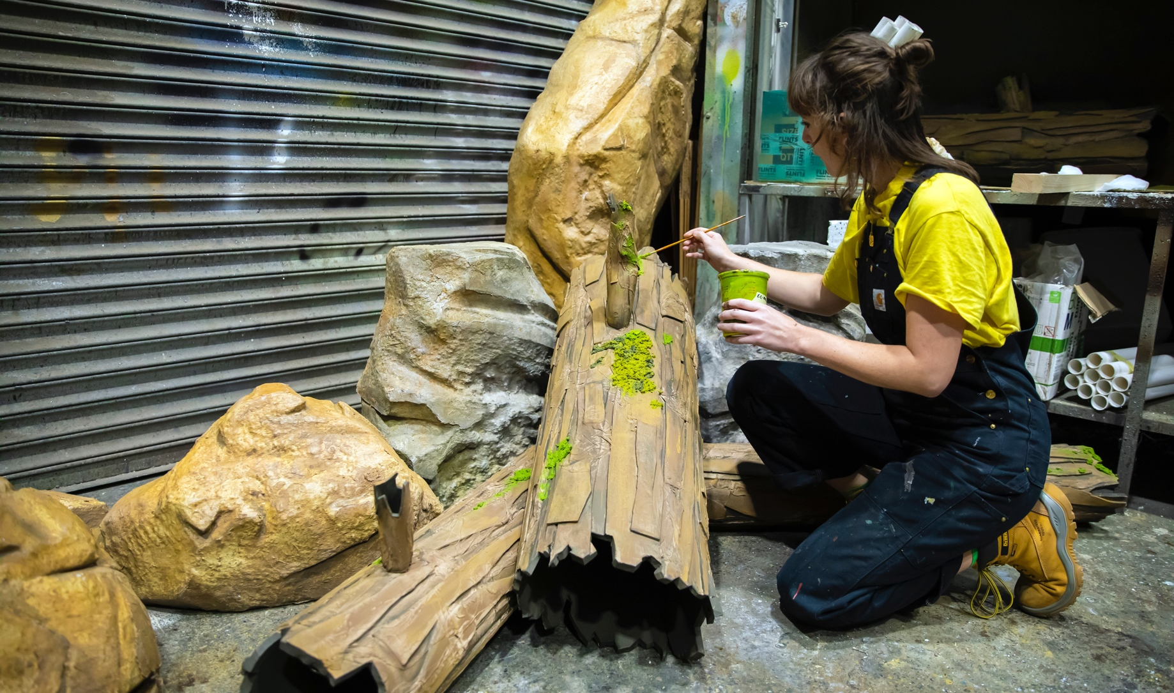
- The successful Jerwood Resident Designer will start on 8th July 2024.

CHECKLIST

Are you familiar with all of the information in this job pack?

Do you meet the eligibility (page 6)?
Have you completed the ‘How to Apply’ questions?
Have you attached a photo or drawing or something you’ve designed?
Have you completed the online monitoring form here?

Please send your answers along with your photo or drawing to production@leedsplayhouse.org.uk with the subject line “Jerwood Resident Designer Application" by Monday 13th May at 10am.

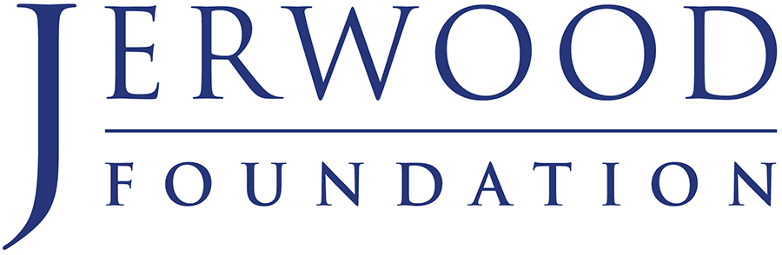
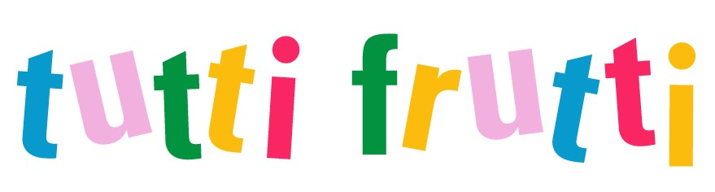
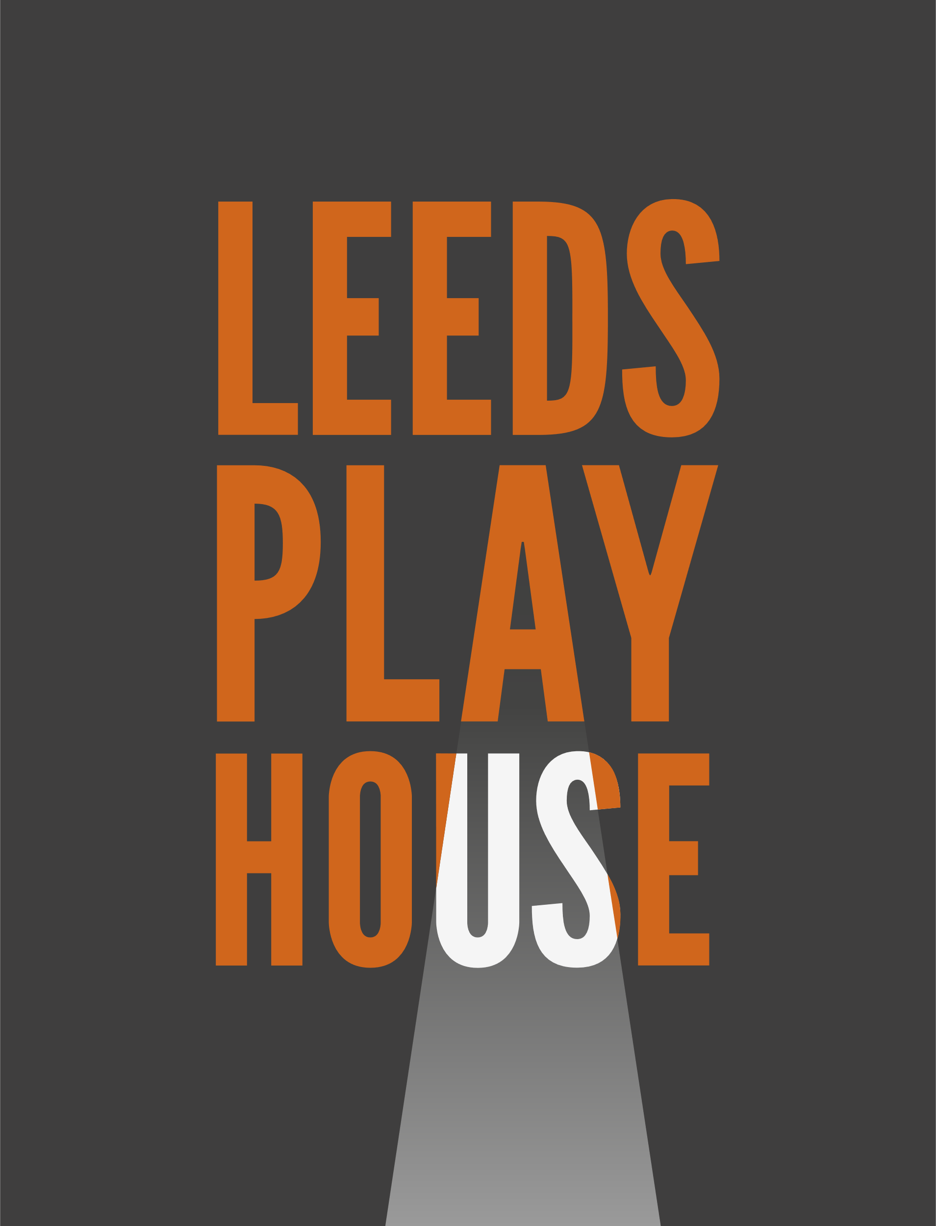

Image credits:
Pg 1 Quarry Theatre taken by Helen Murray
Pg 3 Leeds Playhouse Paint shop taken by Helen Murray
Pg 4 Hedwig and the Angry Inch, designed by Ben Stones, Lighting Design by Katherine Williams, taken by The Other Richard
Pg 5 Jack Frost and the Search for Winter by Joseph Coelho, designed by Warda Abbasi, lighting by Callum Macdonald, taken by Brian Slater
Pg 8 Beautiful Thing designed by Rosie Elnile, Lighting Design by Elliot Griggs, taken by The Other Richard
Pg 10 Rachel Hodgson in Leeds Playhouse Wardrobe Department, taken by Anthony Robling
Pg 11 Leeds Playhouse Soft Furnishing Room taken by Helen Murray
Pg 12 Images of Warda Abbasi and Delicia Sorhaindo taken by Cian O’Riain
Pg 14 Deputy Props Manager Beth Clenton working on The Enormous Crocodile, taken by Pamela Raith

